Utah History: Unit 5
Turn of the Century
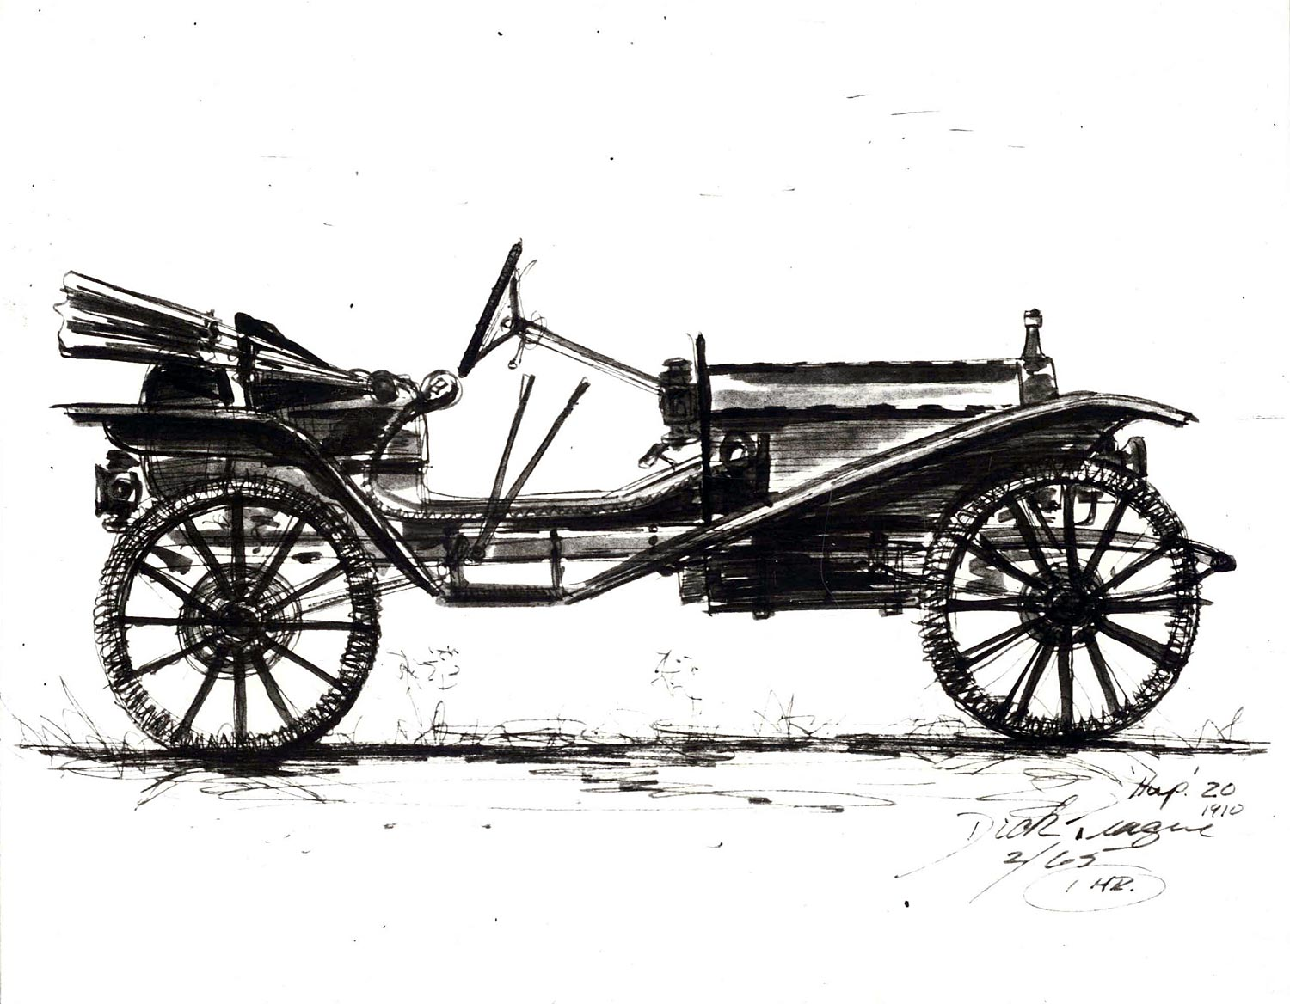
Name: ____________________________________________
Period: ___________________________________________
Due Date: ________________________________________

Unit 5 Guide-o-Rama
Directions: Column 1 is the reading assignment. Column 2 gives you specific instructions for how to read the passage and get the most out of it. You don’t need to write anything in Columns 1 and 2. Write your thoughts in Column 3.

Reading Assignment | While Reading | Write Thoughts
- Read pages 228 and 229 thoroughly. |  | Describe reasons immigrant groups came to Utah during the early 1900s.
- Read page 230 |  | How were African Americans treated in Utah?
- Read page 231 | Look at the pictures of the churches and think about problems minorities in Utah may have faced. | How do you think churches served the needs of Utahns at this time?
- Read page 235 |  | Why did workers form labor unions?  What was the Scofield Mine Disaster?
- Read page 236 |  | What types of things did reformers want to improve?
- Read page 238 |  | What was the controversy surrounding the creation of the Strawberry Reservoir?
- Read page 240 thoroughly, and the grey box at the top of page 241 (“Outbreak of Influenza”). |  | Look at the newspaper on page 240. Answer the question below the newspaper here:  Is a newspaper a primary source?  What is the influenza?
- Read pages 242 and 243 thoroughly. | Make sure to look closely at the pictures. | How did WWI influence the attitude of the 1920s?
- On page 244, read the column under “The Great Depression”. | Take a look at the living conditions of these people by looking closely at page 245. | What does “Bankrupt” mean? (Check glossary if necessary)
- Read page 250 |  | How do the lyrics in “Brother Can You Spare a Dime?” reflect the frustrations of out-of-work Americans at the time?
- On page 246, read the one paragraph under “The New Deal”. |  | Who came up with the “New Deal” Plan?
- Read pages 246-247 |  | What is the difference between the CCC and the WPA?

Immigration and World War I Activity
Immigrant Description | Let them in? WHY? | Immigrant’s Name
Country: Colombia
Age: 35
Gender: Female
Occupation: Musician
Marital Status: Single
Other: Pregnant
Country: China
Age: 18
Gender: Female
Occupation: Military
Marital Status: Single
Other: dishonorable discharge from the military
Country: Japan
Age: 14
Gender: Male
Occupation: Student
Family: Single Mother
Other: 2011 Pokémon Tournament World Champion
Country: Germany
Age: 15
Gender: Female
Occupation: Student
Family: Father, Mother, & Sister
Other: Jewish, Parents former criminals
Country: Greece
Age: 25
Gender: Male
Occupation: Law Enforcement
Marital Status: Single
Other: Healthy
Country: Germany
Age: 56
Gender: Male
Occupation: Politician
Marital Status: Married
Other: Does not drink or smoke
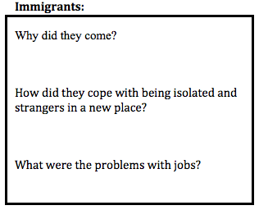
What surprised you about immigrants and immigration decisions?

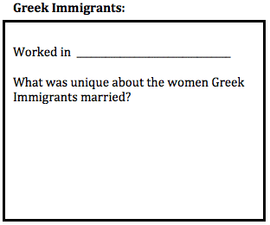
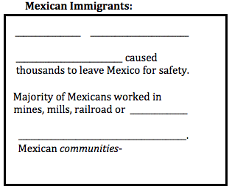

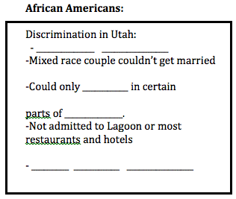
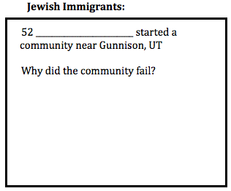
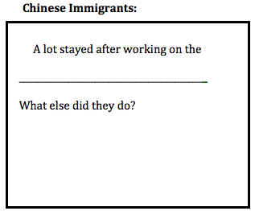
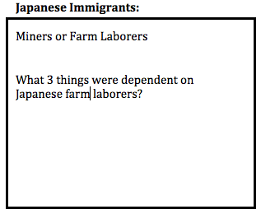

Advancing Technology:
What two ways did technology advance in Utah?

Mining:
What things do we mine in Utah?

Who was Daniel Jackling?

How did Open-pit mining and smelters help Utah?

Why did Mining Labor Unions form?

National Parks
What is the purpose of National Parks?

Utah’s First national park was___________________________________________________________
What was the controversy over Strawberry Reservoir?

Progressive Movement:
What did reformers want the government to help with?
What is Prohibition?
Was the U.S. the only country to pass Prohibition?
Why did prohibition not work in the United States?
Labor Movement:
What were the two main industries in Utah?
What were the problems that industry brought?
What did the mining labor union want?

What would your life have been like if you lived in this time period? What would you be doing?

Food Regulations:
Who was Upton Sinclair and what was the name of his book?

What was it about?

Women’s Suffrage:
What gave all women the right to vote and in what year?

Inventions
What 6 inventions changed life in the 1900s?

World War I
How did World War 1 start?

Who was fighting who?
Triple Entente | The Central Powers
What was WWI like?

Who invented the Machine Gun? Where was he from?

What is Trench Warfare?

What were problems with that type of fighting?

Influenza:
How did state officials try to prevent the spread of the Flu Epidemic?

Child Labor Activity
Guiding Questions
1. What does each photograph suggest about what work was like for children in the Pennsylvania coal mines in 1910 and 1911? Cite specific details from each photograph to support your claims.
Document A

Document B

Document C

Document D

2. What other evidence would you want to see to determine whether these photographs are accurate representations of work in coal mines?

3. Based on the content of the photographs, how do you think Hine felt about child labor? Cite evidence from each of the documents to support your points.

4. When evaluating whether a historical photograph is useful as evidence, historians consider various questions, including:
- When and where was the photograph was taken?
- Who took the photograph? What was their perspective on the events or people being photographed and how might that have influenced what they chose to shoot?
- Why was the photograph taken? Does the photographer have an incentive to portray a scene in a particular way?
- Under what circumstances was the photograph taken? How might these circumstances have limited or enabled what the photographer was able to capture?
- What technology did the photographer use and how might that have influenced the image created? Considering the questions above, why might Hine’s photographs be useful evidence about working conditions for children in the mines at the time?
Considering the questions above, what about the photographs might cause you to question whether they are useful evidence about working conditions for children in the mines at the time?

The Roaring 20’s
Notes on the 1920’s -1930’s
The 1920’s – Please write characteristics of the 1920’s
The 1920’s were also known as …
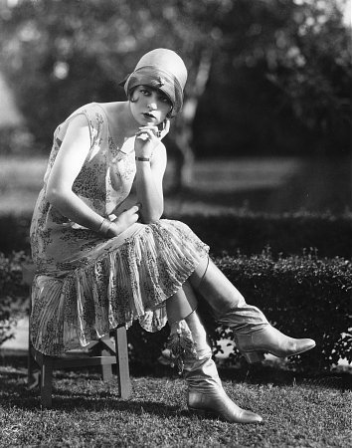
Flappers were…

What was men’s fashion like?
What were the movies like before we introduced sound?
What was the name of the first talking picture (movie with sound)?

What was the Charleston?
What is Jazz?

Who was Alma Richards and what was he good at?
Who was Jack Dempsey?
What did he do to strengthen his jaw?
What would it have been like to live in the 1920’s?
The Great Depression/New Deal

OBJ #1 - Describe the CAUSES and SPARK of the Great Depression. How did Overproduction affect both farmers and industry? What system collapsed and caused millions to lose their savings? Explain how buying on Margin created the Spark. How did people lose money because of the spark?

OBJ #2 -Describe how the Great Depression affected people. Who was the president when it started, and what did he do to help? Who tried to help the poor and what problems did they have? How did people try to escape the Great Depression?

OBJ #3 - Describe the natural disaster that affected the U.S. during the Great Depression. What was the disaster’s nick-name? What caused the disaster? Where did the people go to try and escape their troubles and how were they treated (nick-names for these people)?

OBJ #4 - Describe Franklin Roosevelt’s approach to fixing the Great Depression. What problem did Roosevelt fix first and how? What was Roosevelt’s plan called? Name the three major goals of his plan?

OBJ #5 - Describe the reasons people opposed Roosevelt’s plan. Give two (2) examples of people who opposed Roosevelt. Why? What did the Supreme Court say about the early part of the New Deal? How did Roosevelt try and change their minds? What was the result?

