Utah History Unit One

The Land, American Indians, Mountain Men

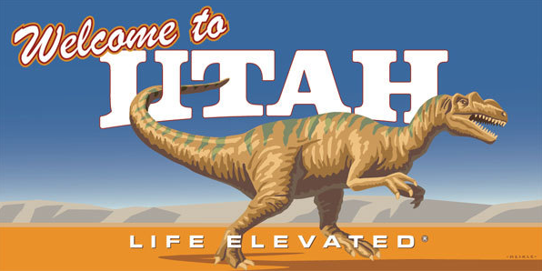

Name: ________________________________

Period: _______________________________

Due Date: ____________________________

Important Due Dates

|  |  |
| --- | --- |
| What is it? | When is it due? |
|  |  |
|  |  |
|  |  |

Calendar

|  |  |  |  |
| --- | --- | --- | --- |
| Date | Objective | Homework | Warm Up |
|  |  |  |  |
|  |  |  |  |
|  |  |  |  |
|  |  |  |  |
|  |  |  |  |
|  |  |  |  |
|  |  |  |  |
|  |  |  |  |
|  |  |  |  |
|  |  |  |  |
|  |  |  |  |
|  |  |  |  |

|  |
| --- |
| **UT History Unit 1: Land, American Indians, Mountain Men**  *Over the next four weeks we will learn about the land and how it supported our first inhabitants.* |

|  |  |  |  |  |  |
| --- | --- | --- | --- | --- | --- |
| ***BIG Question****: What is the relationship between the land and where people live*? | | | | | |
| **Essential Questions:** | | | | | **Your Proof:** | |
| ***(1). What makes the geography of Utah?***  This means that I can name major rivers, lakes, and mountain ranges and where they are located within the three regions of Utah. | | | | |  | |
| ***Rate Your Level of Understanding:*** | | | | |
| **1** | **2** | **3** | **4** | | List pages in the packet helped you understand the essential question. | |
| **Essential Question**  ***(2). Why is one side of a mountain green and the other dry?***  This means that I can explain rain shadow and how it affects life in Utah. | | | | | **Your Proof:** | |
| ***Rate Your Level of Understanding:*** | | | | |
| **1** | **2** | **3** | **4** | | List pages in the packet helped you understand the essential question. | |
| **Essential Question**  ***(3). How do natural forces shape the environment and landscape?***  This means I can explain how mountains are formed, Lake Bonneville was formed, and how erosion works. | | | | |  | |
| ***Rate Your Level of Understanding:*** | | | | |
| **1** | **2** | **3** | **4** | | List pages in the packet helped you understand the essential question. | |
| **Essential Question**  ***(4). What are natural resources and how are they used?***  This means that I can list natural resources in Utah and can tell if they are renewable or non renewable resources. | | | | | **Your Proof:** | |
| ***Rate Your Level of Understanding:*** | | | | |
| **1** | **2** | **3** | | **4** | List pages in the packet helped you understand the essential question. | |

|  |  |  |  |  |
| --- | --- | --- | --- | --- |
|  | | | | |
|  | | | | |
| **Essential Questions: Your Proof:** | | | | |
| ***(5). What are pre historic and historic people?***  This means I can give a definition of what makes a group of people pre historic or historic as well as give examples of both. | | | |  |
| ***Rate Your Level of Understanding:*** | | | |
| **1** | **2** | **3** | **4** | List pages in the packet helped you understand the essential question. |
|  | | | | |
| **Essential Question**  ***(6). Where did the early people in Utah live?***  This means I can list each of the 5 tribes in Utah and show where they lived on a map. | | | | **Your Proof:** |
| ***Rate Your Level of Understanding:*** | | | |
| **1** | **2** | **3** | **4** | List pages in the packet helped you understand the essential question. |
|  | | | | |
|  | | | | |
| Essential Questions: Your Proof: | | | | |
| ***(7). What determines the lifestyle of a group of people in early Utah?***  This means I can list examples of American Indians homes, clothing, and food sources based on the geography of where they lived. | | | | **Your Proof:** |
| ***Rate Your Level of Understanding:*** | | | |
| **1** | **2** | **3** | **4** | List pages in the packet helped you understand the essential question. |
|  | | | | |
| **Essential Question**  ***(8). What impact did Dominguez and Escalante have on American Indian Tribes in Utah?***  This means I can explain how life changed for American Indians after Dominguez and Escalante’s journey through Utah. | | | | **Your Proof:** |
| ***Rate Your Level of Understanding:*** | | | |
| **1** | **2** | **3** | **4** | List pages in the packet helped you understand the essential question. |
| **Essential Questions: Your Proof:** | | | | |
| ***(9). What was the greatest contribution from Mountain Men?***  This means I can explain why they came west and how that impacted future immigrants to the west. | | | |  |
| ***Rate Your Level of Understanding:*** | | | |
| **1** | **2** | **3** | **4** | List pages in the packet helped you understand the essential question. |
|  | | | | |

**Personal Application**

|  |
| --- |
|  |
| What do you want to be remembered for? (give a through explanation of your thoughts and ideas about the question and apply it to this unit and what we remember these groups of people for)  How does your environment impact the way you live? |
| How many minutes did you spend outside of class on work in this packet or reviewing for tests? ____________  What contributed to your success or lack of success in this unit?  What could you do to get more out of your education in future units? |

**Unit 1 Close Reading Guide**

Directions: Column 1 is the reading assignment. Column 2 gives you specific instructions for how to read the passage and get the most out of it. You don’t need to write anything in Columns 1 and 2. Write your thoughts in Column 3.

|  |  |  |
| --- | --- | --- |
| **Reading Assignment** | **While Reading** | **Write Your Thoughts** |
| 1) On page 4, read the entire section under “Geography-the Stage of History”. | While reading, be thinking: “Why is it important to know Geography?” | How do Geography and History connect? |
| 2) Skim (speed read basic ideas) through pages 10-15. | Look specifically at the map on page 10 to see where the 3 regions are. | Name three physical features of each region in Utah:  The Rocky Mountain Region:  The Great Basin Region:  The Colorado Plateau: |
| 3) Read pages 33-34 thoroughly. | Look specifically for how Utah’s mountains were formed. To help you, look at the bold-faced and highlighted words. | What is erosion?  What is a fault?  How were the Rocky Mountains formed?  How were smaller mountains in Utah formed? |
| 4) Look at the timeline at the bottom of pages 42-43, and scan section headings (big, **bold** words) from pages 46-47. Look for important vocabulary words within each section. | Reading the bolded section headers prepares you for what you are about to learn. Using the glossary, find the definition of vocabulary words. | How many years separate the development of the Fremont culture and the Ute tribe moving into Utah?  What is an archaeologist?  What is an artifact?  What does the term “Prehistoric” mean?  What is a culture? |
| 5) On page 48, read the first paragraph under the section heading- “The Paleo-Indians: Nomadic Hunter-Gatherers”.  On page 48, read the paragraph under the section heading- “The Archaic Indians: Desert Gatherers”.  On page 50, read the whole section under the section heading- “Anasazi or Ancestral Puebloans”. | While reading, think about what it means to be Nomadic.  While reading, be looking for what historians have found about these people.  While reading, look specifically for how water influenced these people’s lives. | Take your best guess at what Nomadic means:  Why did hunter-gatherer Natives not live in one place for very long?  How did the weather and water resources in the area affect the lifestyle of these the Anasazi/Ancestral Puebloan peoples? |
| 6) On page 52, read the two paragraphs under the section heading- “The Fremont”.  Go to page 53 and read the “Fremont Indian State Park” box at the top. | While reading, think about where in Utah these people lived.  While reading, think of how you can help preserve these ancient cultures. | How did most of the Fremont Natives live?  What kinds of crops would grow in this area?  Why is it important to balance modern needs for roads, tracks, and buildings with the preservation of historical sites? |
| 7) Look at the map on page 55, and draw in the Historic Native Lands (5 tribes) in the first blank Utah map in Column 3. Label each tribe name in their tribal land.  Look at the map on page 10, and In the second Utah map label the 3 Regions in Utah. | As you draw in the lands, be thinking, “Where in Utah is it warmer and colder? How could this affect these Native American lifestyles?” |  |
| 8) On page 55, look at the map and read the entire column under the section heading- “Historic American Indians.” | While reading, consider how each tribe is different from the others. | List the 5 tribes of Utah:  Which tribe was the largest?  Why did each group have a distinct culture? |
| 9) Look through pages 56 through 61 and just look at the pictures. | As you view the pictures, consider how pictures can deepen your understanding of what you read. | What do these pictures tell you about the Native American lifestyles in Utah? |
| 10) Look at the timeline on page 66-67. | While looking at the timeline, think about the kinds of people that wanted to come to Utah. | Why do you think these events were chosen for the timeline? |
| 11) On page 72, read the first paragraph under the section heading- “Mountain Men”.  On page 73, read the entire section under the section heading- “Rendezvous” and the Beaver Hats text box | Tip: Remember to spend extra time looking over highlighted vocab words and image descriptions on the same page. | How many men moved into the area to trap?  What is a rendezvous?  What does it mean to barter?  What kinds of pelts were the mountain men looking for? Why? |
| 12) Skim pages 75-77, (you don’t have to read each section) to see the most important mountain men in Utah.  On page 79, read the paragraph under the section heading- “The End of an Era.” | While reading, be thinking, “What are the big contributions of mountain men?” | Name 2 contributions that Mountain Men made in Utah.  Why did the trapping business last for so few years? Give at least 2 reasons.  What did mountain men do after the trade was over? |

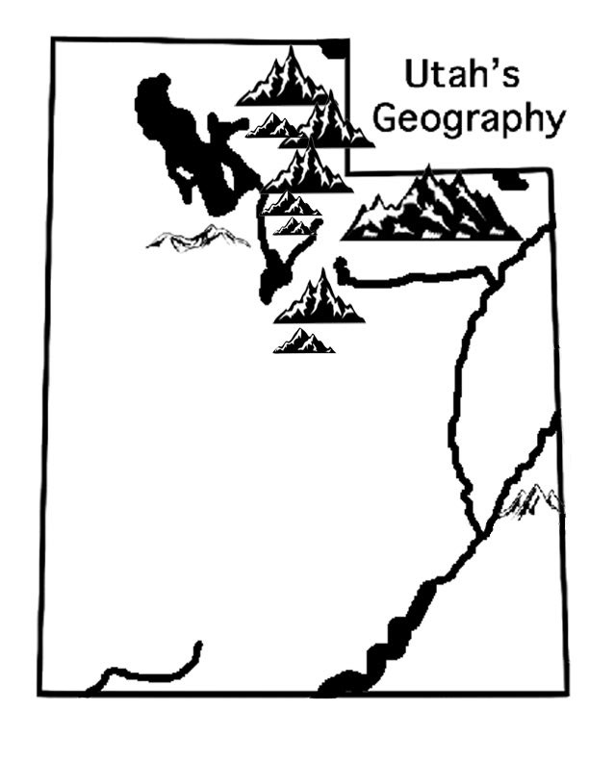

**Label the following rivers, lakes and mountains:**

* Colorado River
* Green River
* Jordan River
* Provo River
* Virgin River
* Strawberry Reservoir
* Flaming Gorge
* Bear Lake
* Great Salt Lake
* Lake Powell
* Utah Lake
* Wasatch Mountains
* Uinta Mountains
* Oquirrh Mountains
* La Sal Mountains

**UTAH GEOGRAPHY FACTS- NOTES**

* Coordinates:
* Climate:
* Elevation:
* Highest Point:
* Precipitation:
* Seasons:

**THREE REGIONS OF UTAH**

* THE____________ _____________
  + Landform:____________ (large, flat _________) surrounded by _____ mountain ranges
  + Streams and rivers from surrounding mountains _____ into the valley floor and form ____________ (Great Salt Lake and Utah Lake)
  + _____________climate
  + _____________ cities in Utah are found along the ____________ of this region, near the _____________
  + Runoff from__________________ give them water
* _The __________________________________
  + _________________ and ________________ Mountain Ranges
  + Most important source of ___________for Utah (runoff from _______ in the mountains)
  + Forests, bears, elk, deer, etc.
  + Campgrounds and hiking trails; ____________a lot of cities
  + Tourists come from all around the world to ____________ in Utah’s mountains
* __The _________________________________
  + Landforms:_______________
  + Covers ________________ of Utah
  + Not a lot of ____________ (desert), but has the _____________ River
  + Rock formations; all__________ of Utah’s National ________ are found in this region
  + _____________________Rock+ ______________= ______________ ______________

**NATIONAL PARKS**

* ___________________________________
* ___________________________________
* ___________________________________
* ___________________________________
* ___________________________________
* **Rain Shadow** 
  + Clouds lose water on the_______________ side of Utah Mountains making it ______________ and have ____________ water for the eastern side making it _______
  + __________________ flows into __________drainage ______________

|  |
| --- |
| Draw a picture illustrating Rain Shadow effect in Utah |
|  |

* **Drainage Regions**
  + _________________Drainage Region: watershed that creates the ______________ ______________ ______________, Utah Lake, Bear Lake, Rivers near there; takes care of major cities
  + ________________ _______________ Drainage Region: watershed that creates the Colorado River, _______________ ______________ and then flows to California
* Draw a map of the two drainage regions in Utah and label them

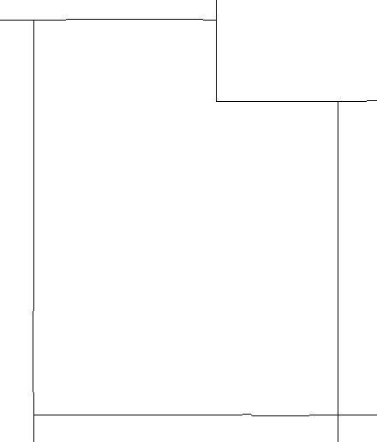

Three Regions Map

Label each of the three regions of the map. (Use page 10 in the book)

Color each region a different color.

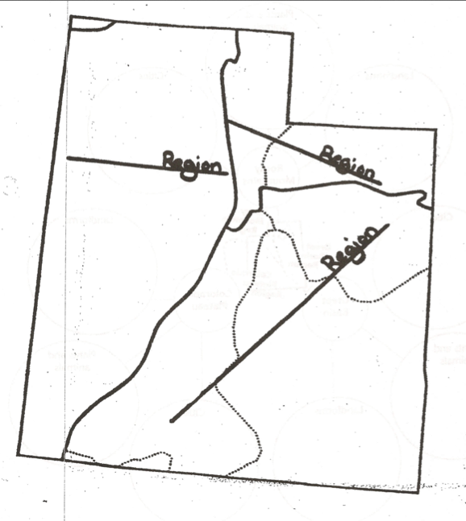

**What’s in the 3 Regions of Utah?**

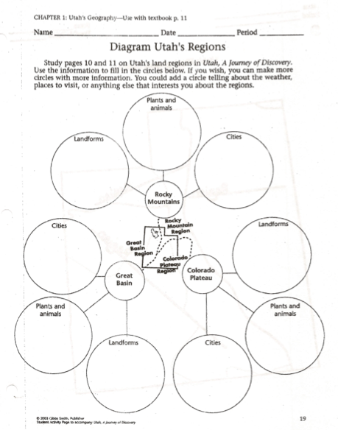**Use your textbook as well as the internet to discover what landforms, plants and animals and cities are located within each of the three regions of Utah. Be sure to put at least three landforms in the circle that is labeled landforms, three plants or animals in the plants and animals circle and three cities in the cities circle for each of the three regions.**

**Ancient Lake Bonneville**

1. Draw and color the outline of Lake Bonneville using a blue/ green colored pencil (found on page 36 in the book).
2. Draw and color Utah Lake, Great Salt Lake, and Sevier Lake using an orange/red colored pencil.
3. Draw a dot and label the following cities: Salt Lake City, Provo, and St George (use the map on pages 9)

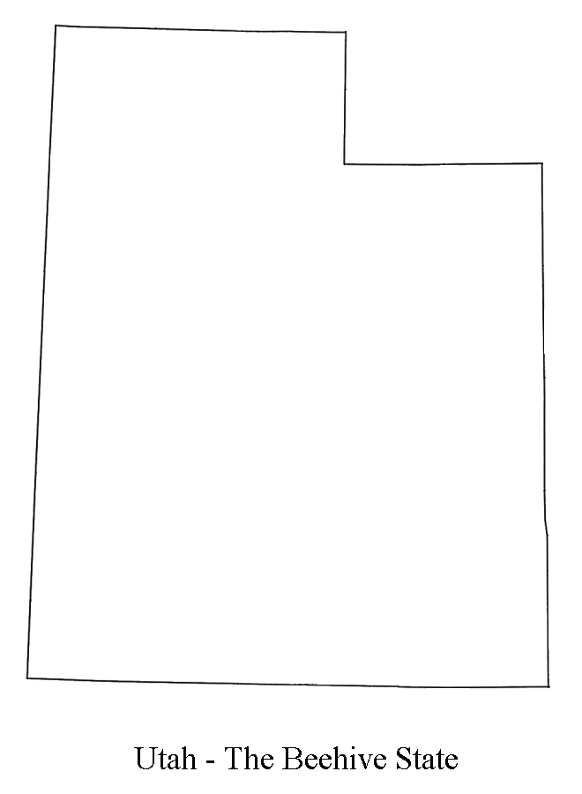

**Now write FIVE facts you learned about Lake Bonneville reading page 35.**



**Prehistoric People of Utah Notes**

* Archeologists: Study early people using __________________________
* ______________________ ______________________: Have no _______________________ _______________________, but we know about them from artifacts, drawings, oral histories
* _______________________ ________________: Have __________________________ records
  + They may have written the records themselves, or someone who interacted with them may have written them
* Danger Cave
  + Hunter-gatherers lived in Utah ________________________ years ago
  + Post-glacial era, right after mammoths and saber toothed tigers
  + Lived in small groups (________ ____________________)
  + _________________: moved from place to place, hunting and gathering
  + Near Wendover
* Hogup Cave
  + First culture harvested _____________________ there to preserve food
  + Second culture, the ___________________, camped there
  + Third culture, the ______________________, tanned hides etc
  + What happened to the cave in 1970? _____________________________________________________________
* Paleo-Indians
  + Nomads that made __________________ with rocks they chipped away with other stones
  + Hunters of _____________________________
* Archaic Indians
  + Lived all over Utah in temporary homes called _________________________ :shelters made of tree branches and limbs
  + Desert gatherers
  + Gathered all kinds of plants and animals
  + Made baskets for gathering things
  + Wove _________________ and blankets (used yucca plants)
  + More ________________________ tools for hunting = the _______________a spear thrower that was held over the shoulder and used to launch the spear forward
    - Allowed the spear to go farther faster and stronger
  + These people mixed with the Anasazi and Fremont
* Anasazi
  + Lived in ___________________________ villages in the four corners area
  + Hunted, gathered, had small ______________________, raised turkeys
  + Developed the bow and arrow
  + Built _____________ to store water and use irrigation
  + Lived in pit houses and ____________ _______________________
* Fremont
  + Lived in the valley of the ____________________ _________________________
  + Were ____________________, hunters, and gatherers
  + Lived in ______________ _____________________________
  + Lived in canyons near rivers
  + Remembered for their __________________ ______________________________
* End of the Fremont and Anasazi
  + Fremont: left villages and became ________________________
  + Anasazi: moved to New Mexico and then disappeared mysteriously
  + Why did they change their lifestyles and disappear?
* How do archeologists use artifacts (a primary source) to determine the culture of a prehistoric tribe?
* Write the difference between prehistoric and historic Native Americans. Give an example of each.

|  |  |  |
| --- | --- | --- |
|  | Write the **DEFINITION** in the box below | Give an **EXAMPLE of a Tribe** in the box below |
| Prehistoric |  |  |
| Historic |  |  |

**Prehistoric People of Utah Notes**

Answer the following questions by taking notes in class or reading pages 46-47 in your textbook. The questions follow in order of the reading.

1. **What is an Archaeologist?**
2. **What is an artifact (define and give a few examples)?**

Fill out thistable by taking notes during class or reading Chapter 3 in your textbook.

|  |  |  |  |  |  |
| --- | --- | --- | --- | --- | --- |
|  | What did they eat? | What kind of houses did they have? | How did they interact with the environment? What part of Utah did they live in? | Interesting Facts (Include any weapons used!) | Where did they go? Theories? |
| **Paleo** |  |  |  |  |  |
| **Archaic** |  |  |  |  |  |
| **Anasazi or Ancestral Puebloans** |  |  |  |  |  |
| **Fremont** |  |  |  |  |  |

* 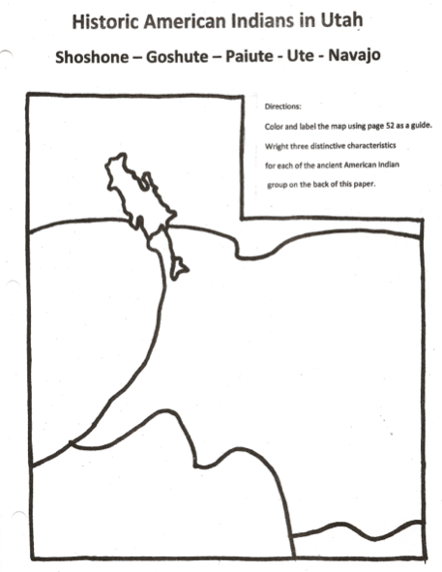

What are the three most distinctive features for each of the five American Indian Tribes in Utah?

Ute

1.__________________________________________________________________________________________________

2.__________________________________________________________________________________________________

3.__________________________________________________________________________________________________

Paiute

1.__________________________________________________________________________________________________

2.__________________________________________________________________________________________________

3.__________________________________________________________________________________________________

Goshute

1.__________________________________________________________________________________________________

2.__________________________________________________________________________________________________

3.__________________________________________________________________________________________________

Navajo

1.__________________________________________________________________________________________________

2.__________________________________________________________________________________________________

3.__________________________________________________________________________________________________

Shoshone

1.__________________________________________________________________________________________________

2.__________________________________________________________________________________________________

3.__________________________________________________________________________________________________

Pick two of the five historic Native American tribes in Utah and describe how those native tribes used the land to develop their culture. Explain the different types of homes they lived in, the different diets or foods they consumed, what types of clothing they wore, and how and what they worshiped as spiritual guidance. (6 pts)

|  |  |
| --- | --- |
| **Name of Tribe:** | **Name of Tribe:** |
| How is their housing related to the land? | How is their housing related to the land? |
| How is their food related to the land? | How is their food related to the land? |
| How is their food related to the land? | How is their food related to the land? |
| How is their religion related to the land? | How is their religion related to the land? |

**5 Tribe QR Code Gallery Walk**

|  |  |
| --- | --- |
| **Shoshone Tribe**  Who lived and travelled in the Shoshone bands?  What kind of shelters/homes did the Shoshone have?  What kinds of food did they eat?  What were their clothes made of?    What were the roles of men, women and children?  What happened when new settlers came to where the Shoshone had lived?  What was the Bear River Massacre? | **Ute Tribe**  What were the two distinct groups of Utes?  What made the groups become larger?  What kind of leaders did they have?  What kinds of clothes did they wear?  What shelters did the Utes live in?  What kinds of food did they eat?  What changed the life of the Utes?  How did it change? |
| **Navajo Tribe**  What do the Navajo call themselves?  What kinds of homes did they live in?  What kinds of food did they eat?  What types of clothes did they wear?  What was the long walk? | **Goshute Tribe**  What does this tribe call themselves?  What did the Goshute eat?  What were their clothes made out of?  What happened to the Goshute tribes after many new settlers come to where they lived?  How were they treated? |
| **Paiute Tribe**  What was the lifestyle and culture of the Paiute tribe?  What were the rituals and ceremonies of the Paiute tribe?  What food did the Paiute tribe eat?  What did the Paiute tribe live in?  What clothes did the Paiute tribe wear?  What weapons did the Paiute tribe use? | Label the 5 Native tribes of Utah. |

Creating your own Tribe

Members of Group: Class period: ____________

___________________________________

___________________________________

___________________________________

___________________________________

___________________________________

*Directions: Using the list you were given, answer the questions below in the spaces provided. In the boxes, feel free to draw pictures (they don’t need to be colored), write key words, and/or write full sentences — whatever helps your group best describe what you are creating. Make sure to thoroughly answer each question!*

What list were you given? (A,B,C,D, or E): _________

What is the name of your civilization? (Make one up): ________________________________________

Why did you choose that name? ____________________________________________________________________________________________________________________________________________________________________________________________

|  |  |
| --- | --- |
| What kinds of houses/shelter will you build? Why? | How will you organize your village? |
| What kinds of clothing would you wear? Would the clothing change with the seasons? Do you have shoes? How do you make them? | How will you manage health? Is their medicine? How will you create medicine? |
| What will you eat? How will you make/catch it? | How will you access water? How will they produce fire? |
| What kind of government would you create? What role will leadership take in your civilization? How will leaders be selected? | What kind of belief system will you have? For example, will you have religion? If so, why would religion be important? |
| Will your people need to trade with other groups to survive? If so, what will they trade, and what will they need in return? Will they have a money system or a bartering system? | What kinds of traditions will your people have? Why? |
| How will you get around? In other words, what will be your transportation system? | If there is anything extra you’d like to add to your civilization, draw/write it here: |

**Dominguez and Escalante Expedition**

Listen to the journal entries and draw where you think Dominguez and Escalante are.



Look on p. 70 to see the actual expedition route. Map it out.



**Great Encounter Map: Spanish Trails**

Key

 Capital City

 Mountain Range

 River

**Use the maps on pages 70 and 78 in the book to complete this assignment.**

1. Draw and label the Escalante-Dominguez Trail with a blue colored pencil.

2. Draw and label the Old Spanish Trail with a red colored pencil.

3. Label the names of the states: California, Utah, Arizona, New Mexico, Colorado, Nevada

4. Label the following cities and mark them with dots: San Francisco, Monterey, San Diego, Mt. Timpanogos, Delta, Milford, Kanab, Santa Fe, Albuquerque, Los Angeles

5. Label the Colorado River and the Great Salt Lake.

Dominguez and Escalante Notes

Open your Utah History textbook to page 70 and start reading in the section titled “The Utes Meet Father Escalante”.

1. Who were Dominguez and Escalante?
2. What were Dominguez and Escalante sent to do?
3. Why did Dominguez and Escalante avoid travelling through Arizona?
4. Why are the journals of Dominguez and Escalante important?
5. Where did Dominguez and Escalante finally arrive, and what did they teach the Timpanogot Indians?
6. How did Dominguez and Escalante want the Indian people to change?
7. What did Indian people see white as a resource for after Dominguez and Escalante left?

**Cause and Effect**

|  |  |  |  |  |
| --- | --- | --- | --- | --- |
| Prior Causes | Causes | Events | Effects | Subsequent Effects |
|  |  |  |  |  |
| Conclusion: | | | | |

**Tall Tale Assignment**

When the mountain men got together, they would tell stories of their exploits. Usually, these stories were exaggerations on what had really happened. This is known as a tall tale. I want you each to type a 1-2 page (double spaced) tall tale of your own. (staple it to the back of the packet) Imagine you are a trapper or mountain man and that you came out to Utah to catch beaver. What interactions did you have with Native Americans, animals, or other mountain men? Please include at least 5 mountain man slang words found on this paper. (underline the mountain man slang words used in your tall tale)

We will be sharing our Tall Tales in class next time in small groups. I would love it if you could tell your story without reading it, however it is fine if you just read it. Get into the story, use an accent or language the mountain men would have used. This will be more fun if everyone gets involved in the activity; have fun! Be a mountain man (or woman).

You do not need to attach this paper to your story.

What were the five mountain man slang words you used? Underline them in your paper.

_____________________, _______________________,_________________________, _____________________,___________________________

**Mountain Man Slang Words**

Big dance= a celebration

Dry= thirsty

Firewater= alcohol or whiskey

Fix= a problem or trouble

Have it on the prairie= to get something for free

Make tracks= to run fast

Outfit= fur company

Possible sack= a leather pouch hung around the neck that contained necessities such as a pope and awl, tobacco and a bullet mold.

Rubbed out= a murder or death

Sign= beaver tracks

Buffler= buffalo

Cache= a hiding place for furs

Critter= animal

Fixins= things needed in the trapping business

Pill= bullet

Give ‘em a teach= teach them a lesson

Make beaver= make money

Para swap= an even trade

Shining Mountains= rocky mountains

The way the stick floats= the way things happened

Vittles= food

**Mountain** **Men of Utah**

|  |  |  |  |  |  |
| --- | --- | --- | --- | --- | --- |
| **Mountain Man** | **Ethnicity** | **Company** | **Location** | **Accomplishments** | **Other Facts** |
| Peter Skene Ogden |  |  |  |  |  |
| Jim Bridger |  |  |  |  |  |
| Jedediah Smith |  |  |  |  |  |
| James Beckworth |  |  |  |  |  |
| Etienne Provost |  |  |  |  |  |
| Antoine Robidoux |  |  |  |  |  |
| Joseph Walker |  |  |  |  |  |

**Government Explorers**

|  |  |  |
| --- | --- | --- |
| Explorer | Date | Accomplishments |
| John C. Fremont | 1841 |  |
| John W. Gunnison | 1849 |  |

|  |  |
| --- | --- |
| **List A**  You live in a Mountainous area with valleys scattered around. The climate is cold (around 20 to 30 degrees Fahrenheit) in the winter and warm to hot in the summer ( around 80-95 degrees Fahrenheit). The winter experiences quite a lot of snow, but not always on a regular basis. There are trees and fertile soil and an abundance of fresh water from nearby lakes and streams.  **Landscape: (There are an abundance of all of these materials)**  Trees: Large Trees (Pine & Quakies)  Bushes  Berries  Fertile soil, but can be rocky in valleys  Lakes and streams  **Animals: (there are an abundance of all of these animals)**  Rabbits, Deer, Elk, Moose, Bear, Mountain Lions, Beaver  Fish, Coyote, Foxes, Squirrels, Raccoons, Snakes  Horses are available by trade, by outsiders  **Currency:**  Human Trade (members of rival groups were often taken captive and used for trading) | **List C**  You live in a Mountainous area with some valleys and canyons. The climate is very, very cold (around 0-20 degrees Fahrenheit) in the winter and warm in the summer (around 70-80 degrees Fahrenheit). It gets cool in the evenings during the summer. The winters have an abundance of snow and ice; when it snows, it stays for a long winter. There are trees and fertile soil and an abundance of fresh water from nearby lakes and streams.  **Landscape: (There are an abundance of all of these materials)**  Trees: Large Trees (Pine & Quakies)  Bushes  Berries  Fertile soil  Granite rock  Lakes and streams  **Animals: (there are an abundance of all of these animals)**  Rabbits, Deer, Elk, Moose, Bear, Mountain Lions, Beaver, Fish, Coyote, Foxes, Squirrels, Raccoons  Snakes, Horses are available by trade, by outsiders |
| **List B**  You live in a dry, desert area. The climate is very warm during the summer (90-115 degrees Fahrenheit) and cool in the winter (55-65 degrees in the winter).  **The landscape includes:**  Red sandstone rocks, plateaus, cliffs  Red sandy dirt  Pinon pitch bushes (small green bushes designed for the desert)  Sagebrush  Small trees, but these are not very common  Cactus, Desert dandelions  In some areas there is a large river, but often has rapids and large canyon cliffs, making it challenging to get to  There are also a few small lakes scattered about, but during dry seasons they can go dry  **Animals of the area:**  Scorpions, Rattlesnakes and other snakes, Lizards, Hawks, Owls, Roadrunners, Badgers, Coyotes, small foxes, bobcats  Jackrabbits, Rats, Bats, Sheep were recently introduced to the area, Some fish, but because water is harder to access, fish is too | **List D**  You live in a very dry climate. Temperatures soar above 100 degrees Fahrenheit in the summer and there is very little rainfall or freshwater supplies. Winters can be cold, with snow, but it varies. The coldest it gets is around 30 degrees Fahrenheit.  **The landscape includes**:  Sand (mostly red, grainy sandstone)  Small, volcanic mountains  Joshua and cedar trees  Cacti  There is a muddy river nearby  **Animals of the area**:  Scorpion, Bat, Sparrow, Bobcat, Owl, Snakes, Raven, Lizard, Rabbit, Cougar, Coyote |
| **List E**  You live in a very dry, desert climate. It is quite a desolate place. Temperatures range from hot (80- 90 Fahrenheit) in the summer and cold in the winters (ranging between 25-30 degrees Fahrenheit).  **Landscape:**  Some mountains, but mostly large, wide valleys  Fine Dirt, Twigs, Sage Brush, Pine Nut, Wild Onion, Carrots, Potatoes, Roots  **Animals:**  Grasshoppers, Red Ants, Crickets, Lizards, Snakes, Small, Fish, Birds, Gophers, Rabbits, Rats, Skunk, Squirrel | | |