Name: ________________________________________________ Class: _________________________________
U.S. History Term 1 Study Guide
Test Date: ______________
Introduction to U.S. History
- What are some reasons to study history?

- Define political and physical map.
- Political map –
- Physical map –

- On the globe draw 0-degree latitude (equator).

- On the globe draw 0-degree longitude (prime Meridian).

- What is the definition of a primary source?

- Give an example of a primary source:

- What is the definition of a secondary source?

- Give an example of a secondary source:

- What is the difference between a fact and an opinion?

Native Americans
- The Inca:
Where did they live?
Who was their emperor?
What was their capital city?
What things are they most remembered for?

- The Mayan:
Where did they live?
What was their capital city?
What things are they most remembered for?
What did they build?

- The Aztec:
Where did they live?
Who was their emperor?
What was their capital city?
What things are they most remembered for?
Who were they conquered by?

- Define the following words:
- Theocracy-

- Carbon dating-

- What determined the culture of American Indians? (Their homes, what they wore, what they ate etc)

- What were the following Indian tribes known for?

- Anasazi
- Inuit
- Iroquois confederacy

- What were some contributing factors that led to the destruction of Native American culture by Europeans?

Explorers

- What two countries led the way in early exploration and had to have the pope divide their claims by drawing the line of demarcation?
- What ocean did explorers cross to come to America?

- Why was Prince Henry the Navigator so important to exploration? Where was he from?

- Name some of the reasons that Europeans wanted to expand their empire. (hint: the 3 G’s)

- Name some of the items that Europeans were looking for in their voyages?

- Who was Bartolome de las Casas and why is he important?

- Explain some of the reasons why Columbus sailed west instead of east to reach the Indies?

- Why did Columbus sail for Spain if he was Italian?

- Where did Columbus believe he had landed?

- What did Marco Polo do when he returned from his years in the Orient?

- What did Magellan do?

- Why is America named after Amerigo Vespucci?

- Who did Cortez conquer?

- What did Europeans gain in the Columbian Exchange?

- What did Americans gain in the Columbian Exchange?

- Why do we speak English, French, Spanish and Portuguese in America today?

13 Colonies

- What was the name of the first permanent English settlement?

- What crop made it possible for Jamestown to survive?

- What was the name of the joint stock company that was sent to the Chesapeake Bay to look for gold and establish trade in fish and furs?

- Who learned how to grow a type of tobacco from the West Indies and married Pocahontas?

- Which experienced soldier was a great leader of Jamestown and coined the phrase, “If you don’t work, you don’t eat!”

- What year was Jamestown founded?

- What year was Plymouth colony founded?

- What was the Mayflower Compact?

- Why did the Pilgrims come to the New World?

- Who were Squanto and Samoset and what did they do?

- What three industries was the economy of the New England colonies based on?

- Free and compulsory public education was characteristic of which group of colonies?

- Which group of colonies was known for religious tolerance and having many different churches?

- Which colonies were primarily known for huge plantations of cash crops like tobacco, rice, indigo, and cotton?

- In the triangular trade, name three products exported from the Americas to Europe?

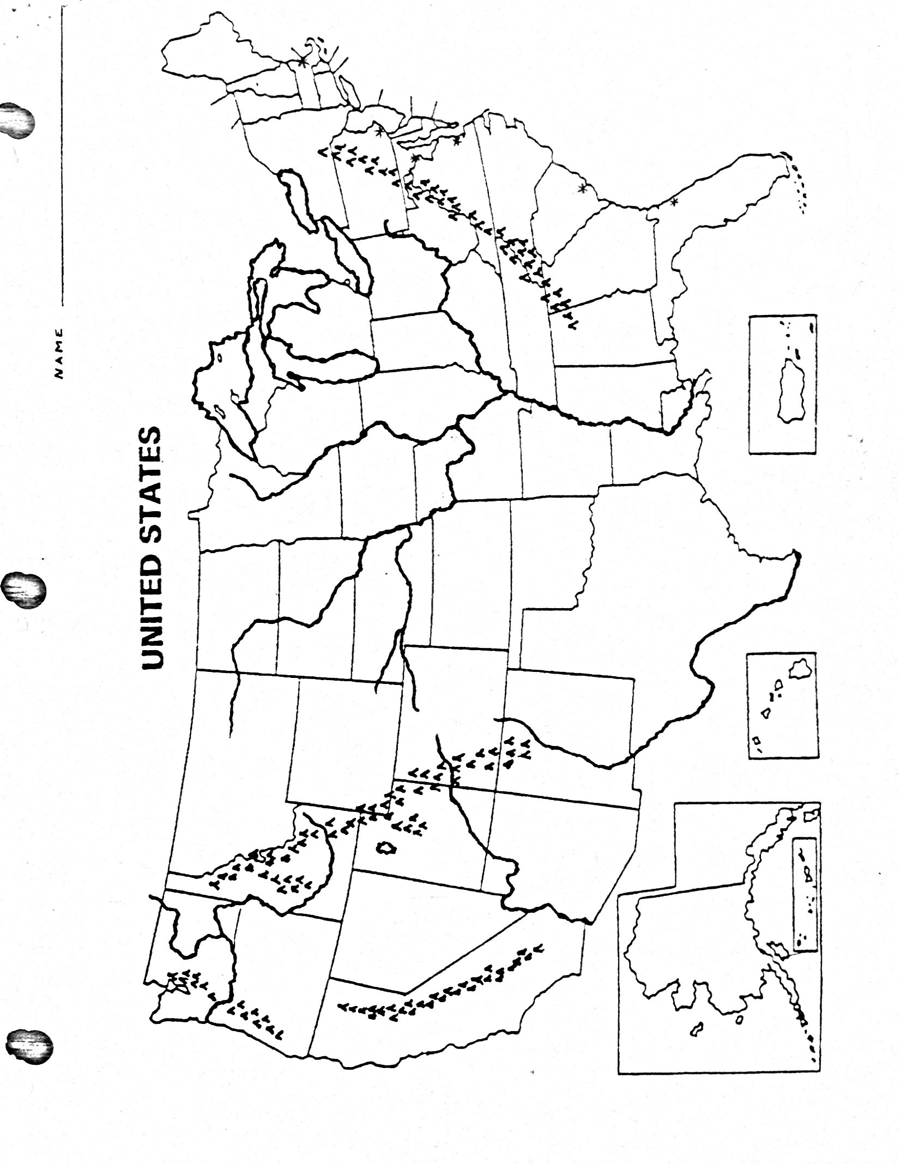
- Label:

- Mississippi River
- Snake River
- Platte River
- Rio Grande River
- Missouri River
- Ohio River
- Colorado River
- Columbia River
- Great Basin
- Great Plains
- Coastal Plains
- Appalachian Mtns
- Sierra Nevada Mtns
- Rocky Mtns
- Cascade Mtns

