**U.S. HISTORY**

**PRE- REVOLUTION**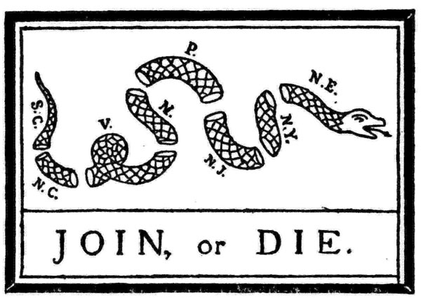

**NAME: ____________________**

**PERIOD:___________________**

**DUE DATE: _________________**

Calendar

|  |  |  |  |
| --- | --- | --- | --- |
| Date | Objective | Homework | Warm Up |
|  |  |  |  |
|  |  |  |  |
|  |  |  |  |
|  |  |  |  |
|  |  |  |  |
|  |  |  |  |
|  |  |  |  |

Important Due Dates

|  |  |
| --- | --- |
| What is it? | When is it due? |
|  |  |
|  |  |
|  |  |
|  |  |

|  |
| --- |
| **US History Unit 4: Pre Revolution**  *Over the next three weeks we will learn what events led to the American Revolution.* |

|  |  |  |  |  |
| --- | --- | --- | --- | --- |
| ***BIG Question: What led to revolution?*** | | | | |
| **Essential Questions:** | | | | **Your Proof:** | |
| ***(1). How did the French and Indian War lead to the start of the Revolutionary War?***  This means that I can explain why the British government started taxing the colonists. I can explain the meaning of “No taxation without representation” | | | |  | |
| ***Rate Your Level of Understanding:*** | | | |
| **1** | **2** | **3** | **4** | List pages in the packet helped you understand the essential question. | |
| **Essential Question**  ***(2). What were the major events/acts that led to the Revolutionary War and what was their impact?***  This means that I can list at least 10 major events/acts that led to the Revolutionary war and put them in cause and effect order. | | | | **Your Proof:** | |
| ***Rate Your Level of Understanding:*** | | | |
| **1** | **2** | **3** | **4** | List pages in the packet helped you understand the essential question. | |
| **Essential Question**  ***(3). What were the patriot and loyalist perspectives and how did the sons and daughters of liberty contribute to the Revolutionary effort.***  This means I can define what a patriot and loyalist believes. I can explain the role/influence of both the sons of liberty and daughters of liberty. | | | | **Your Proof:** | |
| ***Rate Your Level of Understanding:*** | | | |
| **1** | **2** | **3** | **4** | List pages in the packet helped you understand the essential question. | |
| **Essential Question**  ***(4). Where are the 50 states located?***  This means that I can identify all 50 states on a US map. | | | | **Your Proof:**  When is the Quiz?___________________________________________  What score did you receive on the Quiz? ________________________ | |
| ***Rate Your Level of Understanding:*** | | | |
| **1** | **2** | **3** | **4** | List pages in the packet helped you understand the essential question. | |
|  | | | | | |
|  | | | | | |

**Personal Application**

|  |
| --- |
|  |
| Before the Revolution, colonists felt like they weren’t being listened to by the British government. They chanted, ”No taxation without representation”. They believed that every person’s voice mattered and that they should be heard… especially by the government. They went on to create a new government where people all have a voice in government.  Describe a time in your life when you felt like you didn’t have a voice… no one was listening to you. How did it make you feel and why? How did you gain your voice? What do you think are the most effective or moral methods to let your voice be heard? |
| How many minutes did you spend outside of class on work in this packet or reviewing for tests? ____________  What contributed to your success or lack of success in this unit?  What could you do to get more out of your education in future units? |

**Declaration of Independence**

*Please memorize this phrase…*

*there will be a quiz on it in the next unit.*

We hold these truths to be self-evident, that all men are created equal, that they are endowed by their Creator with certain unalienable rights, that among these are life, liberty and the pursuit of happiness.

**The French and Indian War 1754-1763**

**Where is this happening? _______________________________________________________**

**Why are they fighting?__________________________________________________________**

**__________________________________________________________________________________________________________________________________________________________**

**Who did the Indians join? Why? __________________________________________________**

**_____________________________________________________________________________**

**What is the first conflict and how is George Washington involved?______________________**

**_____________________________________________________________________________**

**_____________________________________________________________________________**

**Who was fighting who?**

|  |  |  |  |  |  |
| --- | --- | --- | --- | --- | --- |
| * Draw the flags of the 2 allies  |  |  | | --- | --- | |  |  |   l | * Draw the flags for the 2 allies  |  |  | | --- | --- | |  |  | |

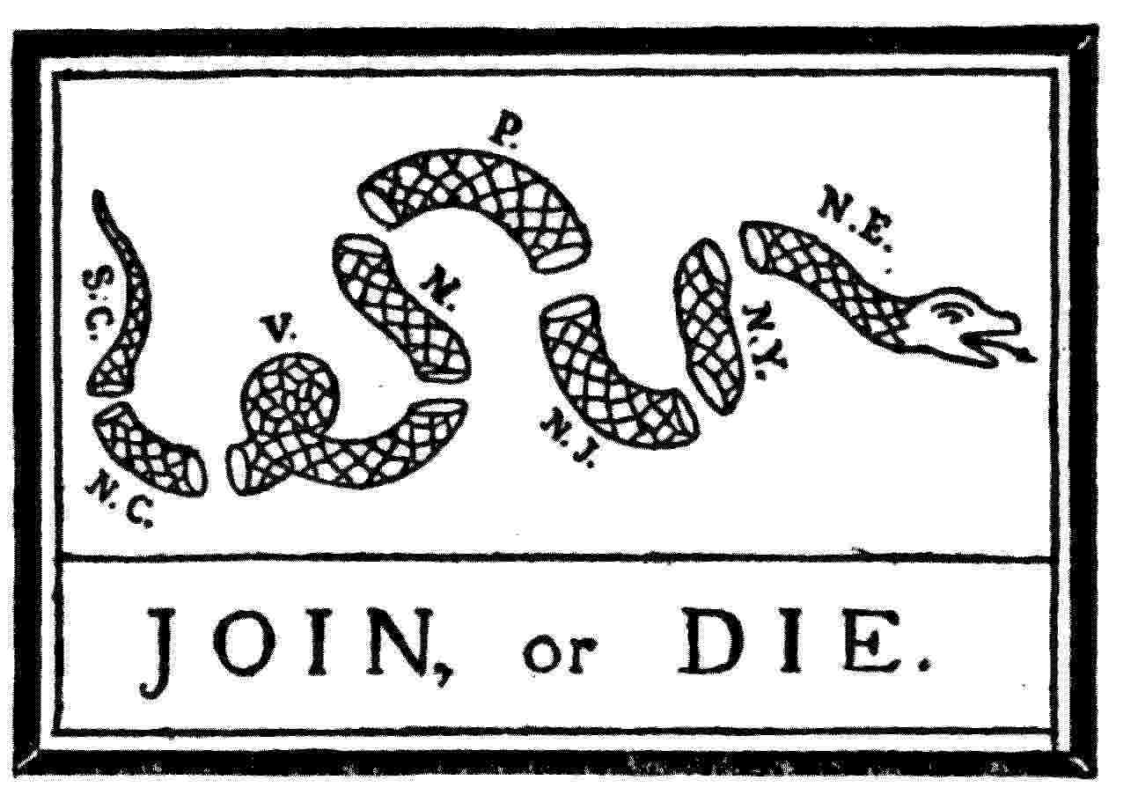**The Albany Plan : __________________________________**

**__________________________________________________________________________________________________**

**What happened at Fort Duquesne? ___________________**

**_________________________________________________**

**__________________________________________________________________________________________________**

**_________________________________________________**

**Fighting Techniques: _______________________________**

**_____________________________________________________________________________**

**_____________________________________________________________________________**

**How does William Pitt change the war? ____________________________________________**

**__________________________________________________________________________________________________________________________________________________________**

**Who wins? _________________ Pontiac’s Rebellion: _________________________________ _____________________________________________________________________________**

**__________________________________________________________________________________________________________________________________________________________**

**How does the French and Indian war set the stage for the American Revolution? _________**

**__________________________________________________________________________________________________________________________________________________________**

**_____________________________________________________________________________**

**Canassatego – In His Own Words**

Canassatego was a chief of the Onondaga Nation and a diplomat for the Iroquois Confederacy. In 1740, Benjamin Franklin printed excerpts from Canassatego’s speeches. As you read Canassatego’s speech, underline the main ideas from the text and try to understand his position on the relationship between the Iroquois people and the local colonists. Be sure to keep track of Canassatego’s point of view and describe your own thoughts as you fill in the chart below.

|  |  |
| --- | --- |
| . . . We know our lands are now become more valuable: the white people think we do not know their value; but we are sensible that the land is everlasting, and the few goods we receive for it are soon worn out and gone. For the future we will sell no lands but when Brother Onas [the proprietor of Pennsylvania] is in the country; and we will know beforehand the quantity of the goods we are to receive. Besides, we are not well used with respect to the lands still unsold by us. Your people daily settle on these lands, and spoil our hunting. . . .  If you have not done anything, we now renew our request, and desire you will inform the person whose people are seated on our lands, that that country belongs to us, in right of conquest; we having bought it with our blood, and taken it from our enemies in fair war. . . .  It is customary with us to make a present of skins whenever we renew our treaties. We are ashamed to offer our brethren so few; but your horses and cows have eat the grass our deer used to feed on. This has made them scarce, and will, we hope, plead in excuse for our not bringing a larger quantity: if we could have spared more we would have given more; but we are really poor; and desire you’ll not consider the quantity, but, few as they are, accept them in testimony of our regard. . . .  Our wise forefathers established union and amity between the Five Nations. This has made us formidable. This has given us great weight and authority with our neighboring nations. We are a powerful Confederacy, and by your observing the same methods our wise forefathers have taken you will acquire fresh strength and power; therefore, whatever befalls you, do not fall out with one another. | **What are three Key Ideas:**  **Quote: Underline a quote and mark it as quote #1**  **I think Canassatego meant:**  **Quote: Underline a quote and mark it as quote #2**  **I think Canassatego meant:**  **Quote:Underline a quote and mark it as quote #3**  **I think Canassatego meant:**  **I think that Canassatego’s statements on the relationship between the Iroquois and colonists was __________________________**  **(convincing/questionable), because….** |

Analyzing a Political Cartoon: Analyze the political cartoon below and fill in the graphic organizer based on the information you learn from it. When you examine the document be sure to look for the source, date, symbolism, bias, tone, and point of view.

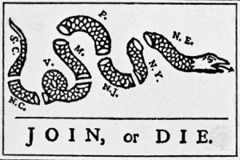

“Join, or Die,” by Benjamin Franklin, *Pennsylvania Gazette* (Philadelphia, PA), May 9, 1754. Courtesy, Library of Congress

|  |  |
| --- | --- |
| I see… | It means… |
|  |  |
|  |  |
|  |  |
|  |  |

**Robert Moses- In His Own Words** – Read the diary of New Hampshire militia soldier Robert Moses from 1755. As you read the document, underline the main ideas from the text and try to understand the experiences Moses depicts from the French and Indian War. Be sure to keep track of Moses’s point of view and describe your own thoughts as you fill in the chart below.

|  |  |
| --- | --- |
| **What are three Key Ideas:**  **Quote: Underline a quote and mark it as quote #1**  **I think Moses meant:**  **Quote: Underline a quote and mark it as quote #2**  **I think Moses meant:**  **Quote: Underline a quote and mark it as quote #3**  **I think Moses meant:**  **I think that Robert Moses’s diary shows us that the French and Indian war was______________________ because…** | . . . We were informed that a number of Indians killed two men in a very barbarous manner. Destroyed eight cattle carried away the value of three. A scout consisting of thirty men pursued them on Friday July 25th [1755] but could not discover them . . . we received intelligence that a number of  Indians supposed to consist of one hundred killed two men about two miles from the Fort, took the man’s heart and cut it in two and laid it on his neck, and butchers the other most barbarously, sought a house near the Fort, wounded one man that he died about an hour after our arrival . . .    Sabath day 7th [of September]: in the afternoon one of the Mohawks that came in informed Colonel Blanchard that he discovered a vast number of French & Indians about 4 miles from the camp & tract [tracked] thirty about a mile from the Camp. The Colonel ordered a scout of one hundred and 20 men to go and know the certainty of it, who returned and made no discovery excepting few tracks which they supposed was made by some of their own men which were a hunting. Monday the 8th: day of Sept 1755—a scout went out from Lake George commonly called by the Indians Lake Sacremaw, under the command of Colonel Williams being in number [six] hundred they receiving intelligence that an Army of French & Indians were on the borders and that their intention chiefly was to beset Fort Lymon. The Colonel with his men was making the best of his way down to relieve them in case any such emergency should happen but he had not marched not exceeding 4 miles from the Lake when he entered where the Enemy ambushed themselves on each side of the path in the form of a half moon. The Colonel had no sooner come up, with his men conveniently in the midst of them but he was fired on every quarter very briskly the Colonel with his men behaved themselves courageously for some minutes but [were] overpowered by such a vast company their number supposed to consist of 2500 men compelling Colonel with his 600 to fight upon a retreat until they came to the Fort at the Lake.  The Enemy pursued them very boldly with their firelocks shouldered and their Bay[o]nets fixed to them marched in towards ye Front of our Army and thought to rush into the camp. They in the camps took them to be New Hampshire forces never fired a gun until the Enemy came so near them that they could discover a Frenchman from an Englishman upon which discovery the whole camp was alarmed & withstood them on the front fixed their cannons and played on them for an hour with the loss of many men to the French who they immediately begin to charge on the right & left . . . but at both places they met with strong resistance. The Indians on the left wing were so ambitious that they would fain enter into the Artillery ground. Two cannon were mounted on that quarter one of which being fired on them swept away sixteen which put the rest in such a terror that they drawed off as quick as possible.  The Regiments which were camped at Fort Lymon distance from the lake 14 miles heard the cannons roaring . . . immediately dispatched to the Lake the New Hampshire Regiment together with part of New York Regiment which number met the enemy after they drawed off from the Lake with a new salutation of firelocks, cutlasses and hatchets playing on every quarter with much effusion of blood but our New Hampshire forces being fresh & courageous and the Enemy tired and much discouraged with the Defeat they met with, retreated and made their escape toward a Creek. The next day they were pursued and a vast quantity of plunder was taken up which they dropped in the [creek]. The day after the battle three Frenchmen were taken up by the Guard at Fort Lymon who upon examination declared that their Army was entirely broke . . . |

**Minavavana – In His Own Words**

Minavavana was a chief of the Chippewa or Ojibwe Nation and a close ally of the French during the French and Indian War. In 1761, a British fur trapper named Alexander Henry recorded Minavavana’s statement to him as he traveled into a French‐allied Chippewa Nation. As you read Minavavana’s speech, underline the main ideas from the text and try to understand his position on the Chippewa way of war and the future to come. Be sure to keep track of Minavavana’s point of view and describe your own thoughts as you fill in the chart below.

|  |  |
| --- | --- |
| Englishman, although you have conquered the French, you have not yet conquered us! We are not your slaves. . . .  Englishman, our father, the king of France, employed our young men to make war upon your nation. In this warfare, many of them have been killed; and it is our custom to retaliate, until such time as the spirits of the slain are satisfied. But, the spirits of the slain are to be satisfied in either of two ways; the first is by the spilling of the blood of the nation by which they fell; the other by covering the bodies of the dead, and thus allaying the resentment of their relations. This is done by making presents.  Englishman, your king has never sent us any presents . . . wherefore he and we are still at war; and, until he does these things, we must consider that we have no other father, nor friend, among the white men, than the king of France. . . . You do not come armed, with an intention to make war. . . . We shall regard you, therefore, as a brother. . . . As a token of our friendship, we present you with this pipe, to smoke. | **What are three Key Ideas:**  **Quote: Underline a quote and mark it as quote #1**  **I think Moses meant:**  **Quote: Underline a quote and mark it as quote #2**  **I think Moses meant:**  **Quote: Underline a quote and mark it as quote #3**  **I think Moses meant:**  **I think that Minavavana’s statements to English trader Alexander henry were ______________________(convincing/ questionable), because ….** |

**Artifacts from the French and Indian War**

|  |
| --- |
| **Artifact** |
| **1) What is it…**  What type of object is it?  What is its shape or size?  What is it made of?  How was it made? |
| **2) Who made it…**  What kind of knowledge did the maker have?  Was it made for one person or a group of people? (who?) |
| **3) What was the occasion…**  When and where was it made?  Did it change over time?  What events or conditions might have affected it? |
| **4) What was the purpose of making it…**  Why was it made?  Was there a hidden purpose?  Who would benefit or be harmed?  How was it actually used? |
| **5) Form whom was it made…**  Who were the intended users?  Did other people use it?  How might the users have reacted to it? |

**The Road to Revolution**

|  |  |
| --- | --- |
| You must scan these events in order. Scan the QR code in the classroom and either answer the questions that go along with the event or create a visual (follow the instructions). | **1754-1763 French and Indian War (visual)** |
| **1763 Proclamation Line:** Where is the line?  Why did the British set this line?  How did colonists feel about the boundary**?** | **1764 Sugar Act:** What was the Sugar Act?  What was the purpose of the Sugar Act?  What was the effect of the Sugar Act? |
| **1765 Stamp Act:** What was the Stamp Act?  How did this unite colonists?  Did the stamp act get repealed? | **1765 Stamp Act Congress: (visual)** |
| **1766 Declaratory Act:** What was it?  What was the relationship between Parliament and the colonists at this point**?** | **1767 Townshend Act:** What imports were taxed? 1:  2:  3:  4:  5:  6:  How did colonists protest?  Was it repealed? |
| **1768 The Liberty Incident: (visual)** | **1770 The Boston Massacre (visual)** |
| **1772 Committee of Correspondence (visual)** | **1772 The Gaspee Incident: (visual)** |
| **1773 The Boston Tea Party: (visual)** | **1774 Intolerable Acts:** Name the 5 laws and what each did:  1:  2:  3:  4:  5: |
| **1774 First Continental Congress:** What was it? | **1775 Battles of Lexington and Concord:** What did it start? |

**Chapter 5 Road to Independence Vocab Activity**

Write a definition in your own words. Keep your definition super short.

1. Writs of Assistance:__________________________________________________________________________
2. Effigy__________________________________________________________________________________________
3. Boycott________________________________________________________________________________________
4. Import_________________________________________________________________________________________
5. Export ________________________________________________________________________________________
6. Repeal_________________________________________________________________________________________
7. Propaganda___________________________________________________________________________________
8. Sons of Liberty_______________________________________________________________________________
9. Daughters of Liberty ________________________________________________________________________
10. Militia________________________________________________________________________________________
11. Minutemen___________________________________________________________________________________
12. Loyalist_______________________________________________________________________________________
13. Patriot _______________________________________________________________________________________
14. Loyalist_______________________________________________________________________________________
15. Petition ______________________________________________________________________________________
16. Preamble_____________________________________________________________________________________
17. Salutary Neglect ____________________________________________________________________________

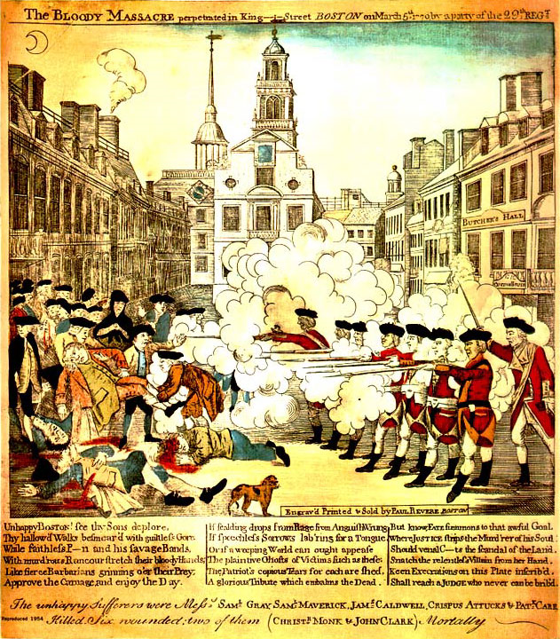**The Boston Massacre**

**Images**

|  |  |
| --- | --- |
| Image 1  What do you see in this image?  What evidence does it provide about what happened at the Boston Massacre? | Image 2  What do you see in this image?  What evidence does it provide about what happened at the Boston Massacre? |

**Newspapers**

Read the two newspapers and summarize each author’s opinion on the two opposite sides of the diagram. In the middle write what happened in the Boston Massacre that they both agree on.

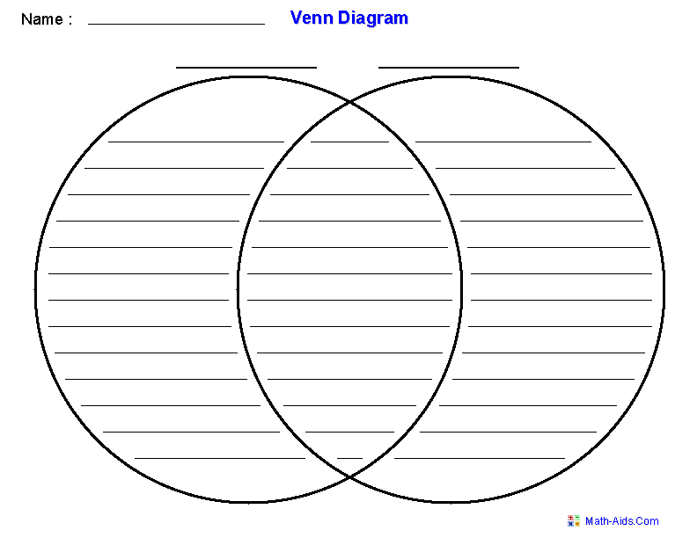

**The Boston Massacre Sources**

|  |
| --- |
| **Document A** |
| **Sourcing** (Answer these questions before reading the document)  1) Who was Thomas Preston?  2) When was it written?  3) Why was it written?  4) what do you predict this document will say? |
| **Close Reading**  5) According to this document, what happened at the Boston Massacre?  6) According to this document, who was responsible for the Boston Massacre? |
| **Corroboration**  7) How is this account similar or different from the accounts provided by the two images? |
| **Reliability**  8) How trustworthy is this account of what happened at the Boston Massacre? Explain your reasoning. |

|  |
| --- |
| **Document B** |
| **Sourcing** (Answer these questions before reading the document)  1) Who was Samuel Drowne?  2) What kind of document is this?  3) When was this document created?  4) what do you predict this document will say? |
| **Close Reading**  5) According to this document, what happened at the Boston Massacre?  6) According to this document, who was responsible for the Boston Massacre? |
| **Corroboration**  7) What details about the Boston Massacre do documents A and B have in common?  8) What details about the event are different?  9) How is this account similar or different from the accounts provided by the two images? |
| **Reliability**  10) How trustworthy is this account of what happened at the Boston Massacre? Explain your reasoning. |

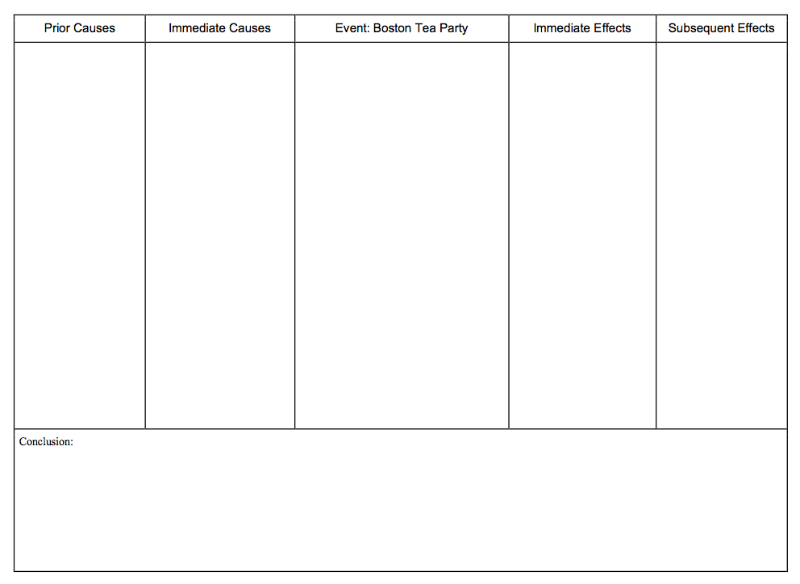

**Practice Test for States**

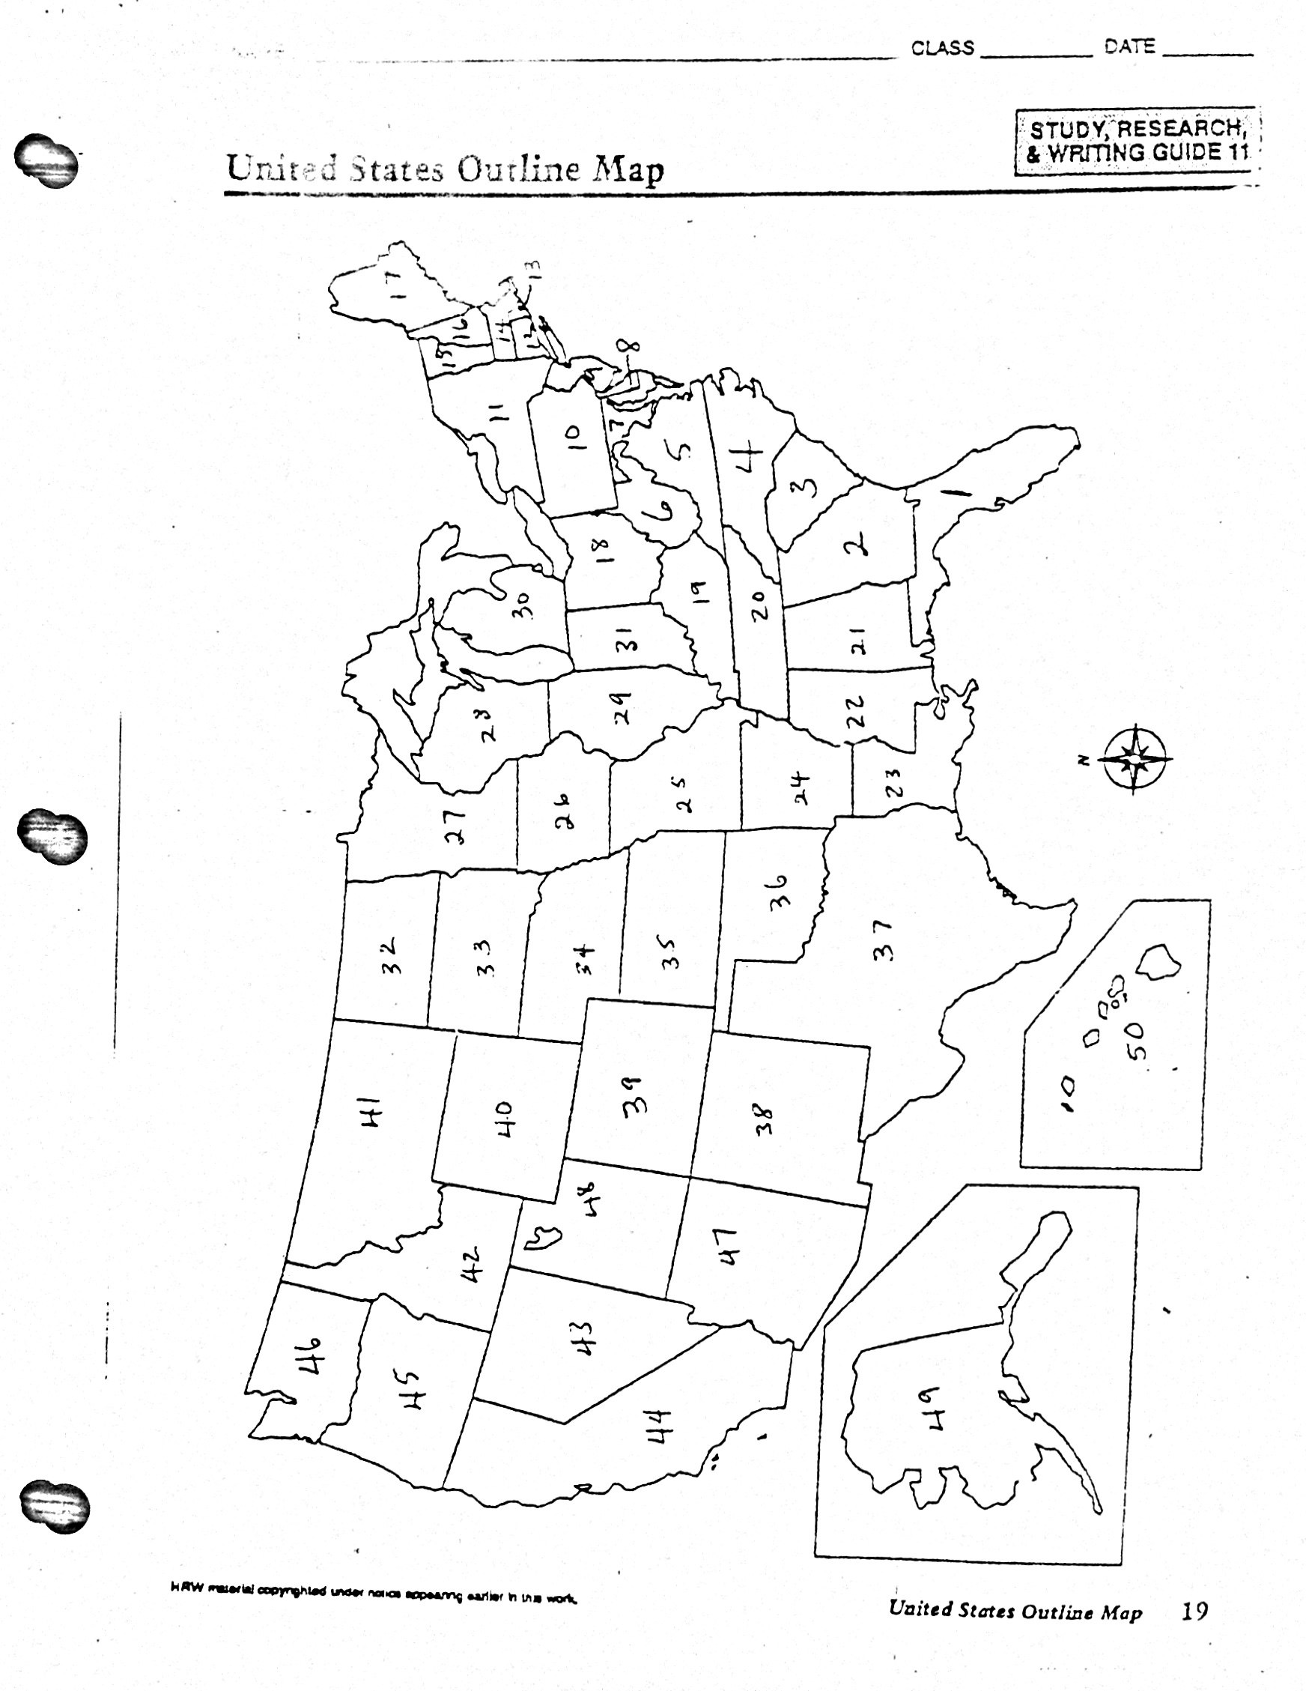Name the state that corresponds with the number on the map.

|  |  |
| --- | --- |
| 1. ______________________________ 2. ______________________________ 3. ______________________________ 4. ______________________________ 5. ______________________________ 6. ______________________________ 7. ______________________________ 8. ______________________________ 9. ______________________________ 10. ______________________________ 11. ______________________________ 12. ______________________________ 13. ______________________________ 14. ______________________________ 15. ______________________________ 16. ______________________________ 17. ______________________________ 18. ______________________________ 19. ______________________________ 20. ______________________________ 21. ______________________________ 22. ______________________________ 23. ______________________________ 24. ______________________________ 25. _____________________________ | 1. ___________________________________ 2. ___________________________________ 3. ___________________________________ 4. ___________________________________ 5. ___________________________________ 6. ___________________________________ 7. ___________________________________ 8. ___________________________________ 9. ___________________________________ 10. ___________________________________ 11. ___________________________________ 12. ___________________________________ 13. ___________________________________ 14. ___________________________________ 15. ___________________________________ 16. ___________________________________ 17. ___________________________________ 18. ___________________________________ 19. ___________________________________ 20. ___________________________________ 21. ___________________________________ 22. ___________________________________ 23. ___________________________________ 24. ___________________________________ 25. ___________________________________ |

**The Road to Revolution Project**

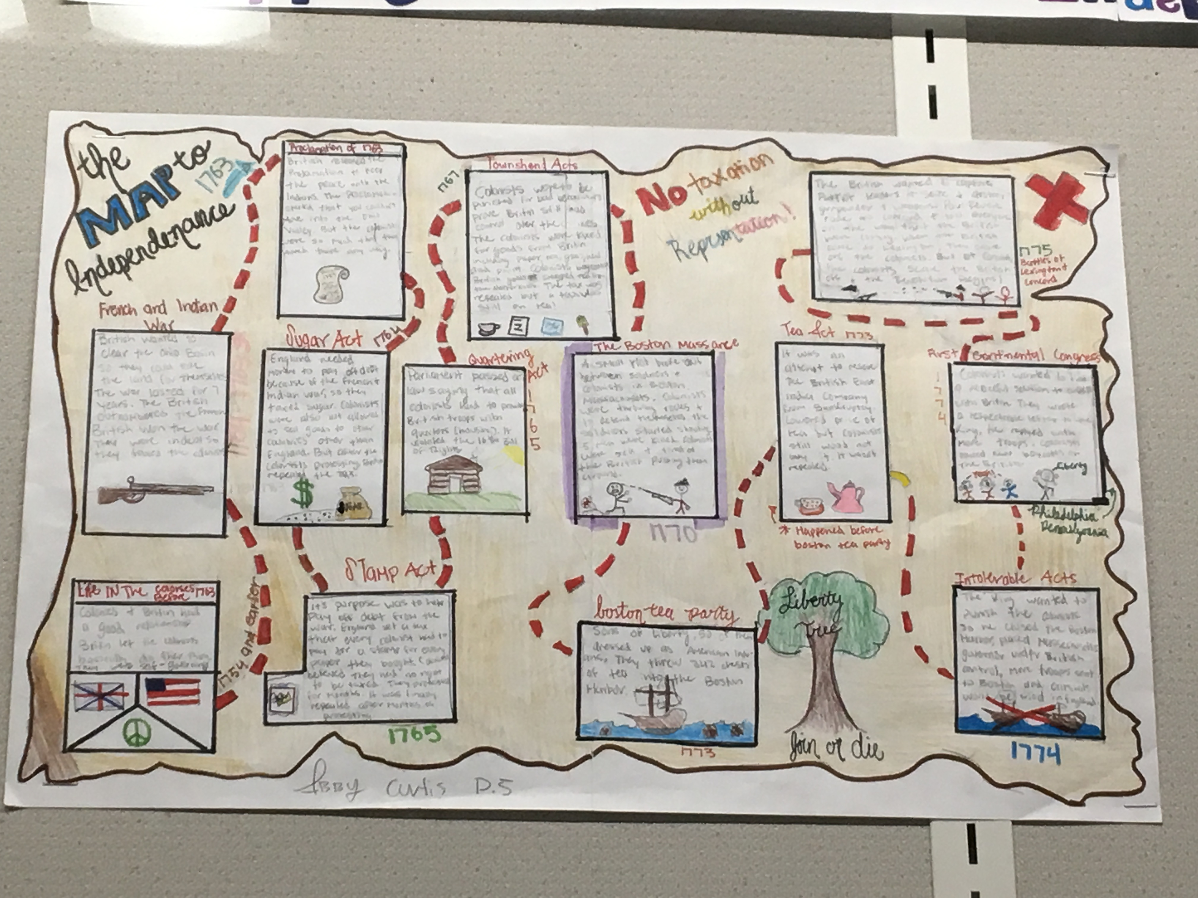

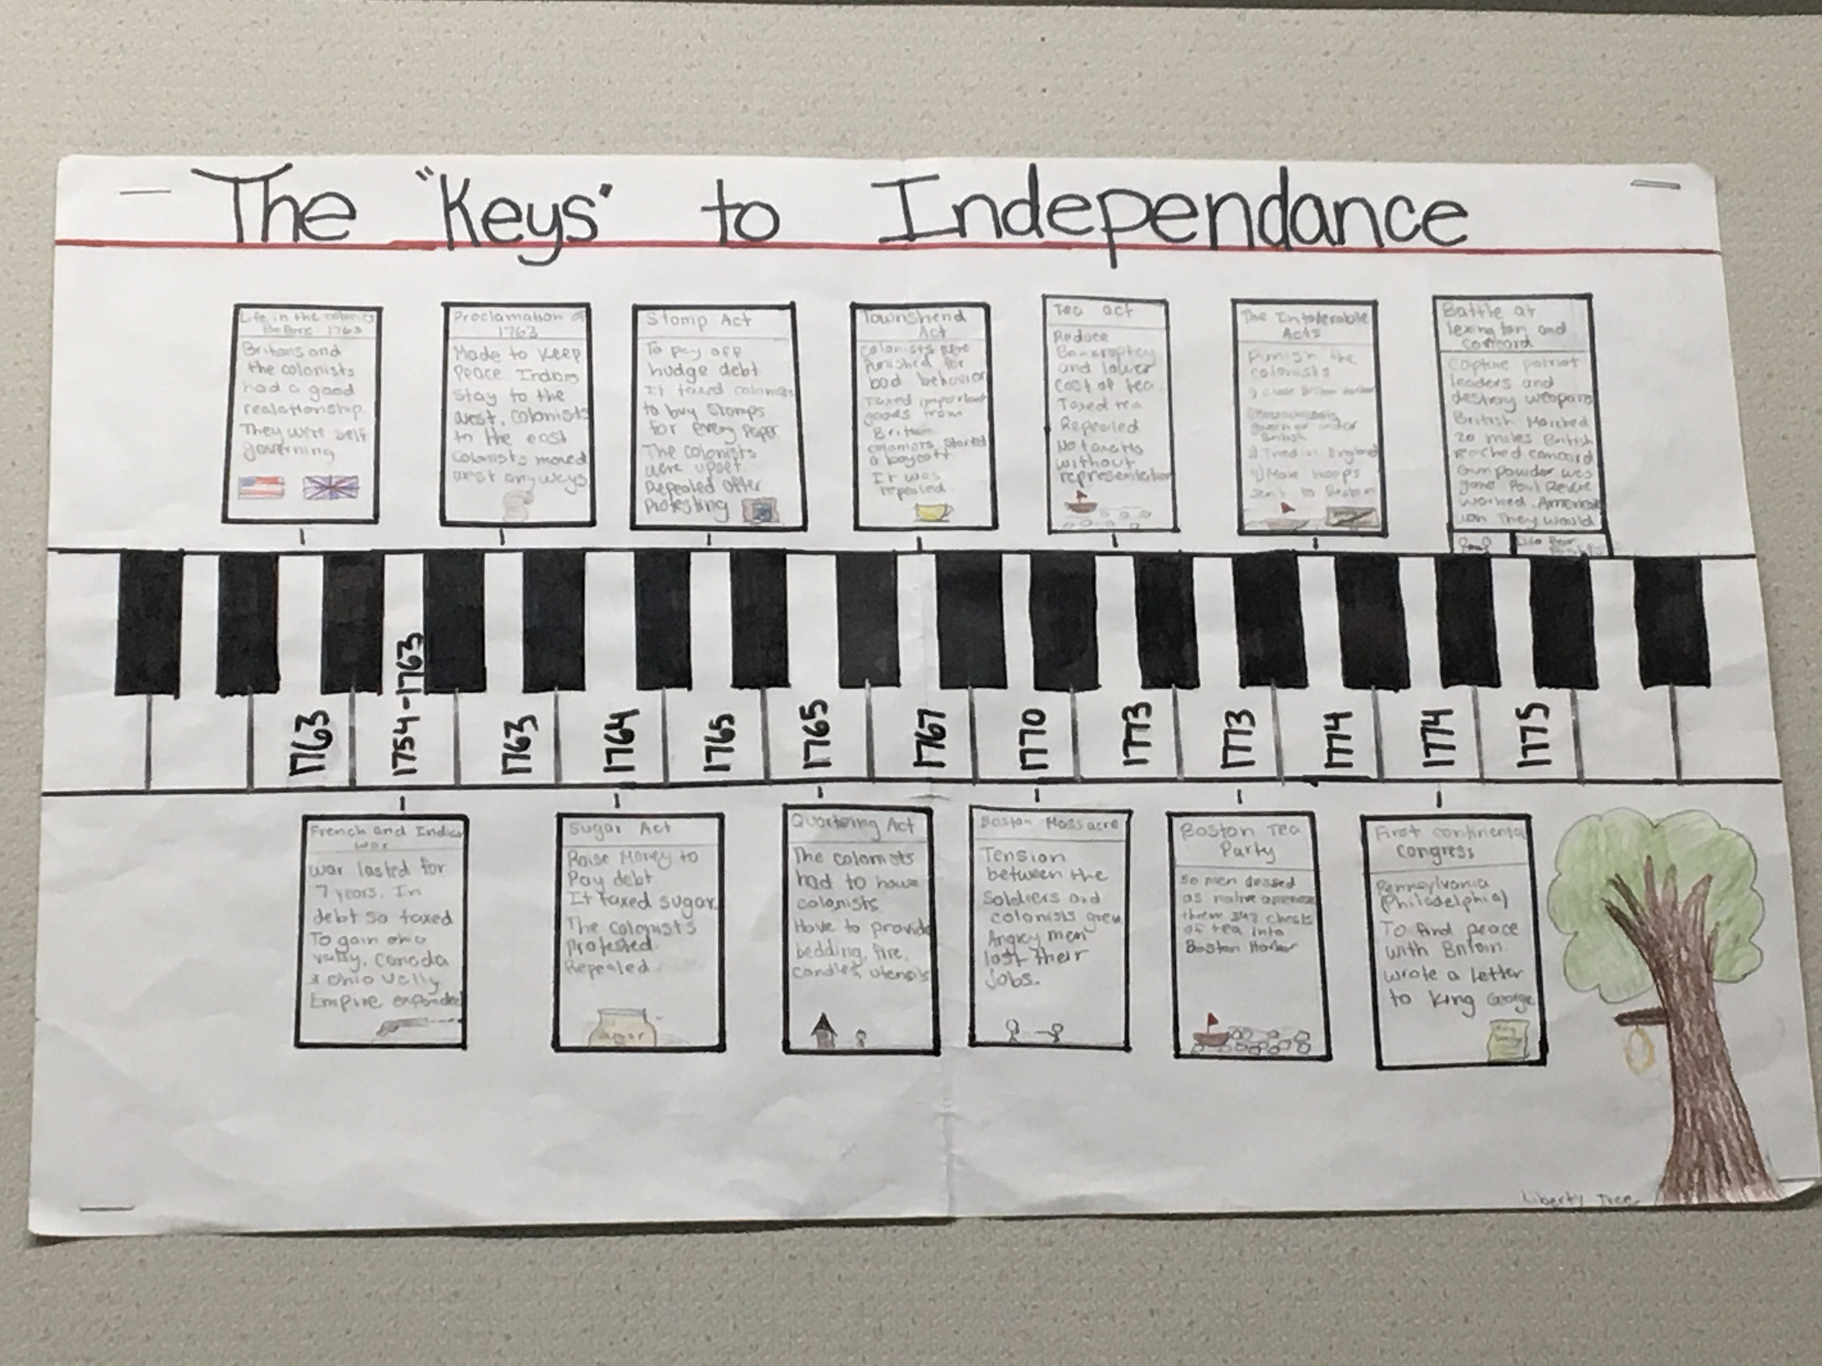The American Revolution did not start overnight. Instead, it started over a series of events spread over 20 years that created one spark after another, until finally…



Revolution!

Your assignment is to capture these events and put them into one, high-quality project that shows the events leading to the war. You have 3 options to choose from. Any option you choose must include the following:

|  |  |
| --- | --- |
| **1: All 16 events HAVE TO BE ON THE TIMELINE!**  1754-1763 French and Indian War  1763 Proclamation Line  1764 Sugar Act  1765 Stamp Act  1765 Stamp Act Congress  1766 Declaratory Act  1767 Townshend Act  1768 The Liberty Incident  1770 The Boston Massacre  1772 Committee of Correspondence  1772 The Gaspee Incident  1773 The Boston Tea Party  1774 Intolerable Acts  1774 First Continental Congress  1775 Battles of Lexington and Concord | **2: You must include at least TEN pictures or illustrations of the events.** (pictures must be colored) |
| **3: You must include at least TEN summaries of events in a paragraph each.** (3-5 sentences) |
| **Macintosh HD:Users:apple:Desktop:2018-04-28 14.22.50.jpg** |

**Choose ONE option**

|  |  |  |
| --- | --- | --- |
| **Option #1**: | **Option #2**: | **Option #3:** |
| Using the 11x17 paper given to you in class, create a high quality “**timeline**” summarizing the events which led the colonists to seek their independence from England.  Your timeline should contain at least **10** pictures or illustrations. It should also include a summary of at least **10** of the events in the form of a well written paragraph. It must include **ALL 16** events listed above. It will be graded on completeness, creativity, and quality. | Using the 11x17 paper given to you in class, create a high quality “**Cause and Effects**” chart summarizing the events which led the colonists to seek their independence from England. Your “Cause and Effects” chart should contain at least **10** pictures or illustrations.  It should also include a summary of at least **10** of the events in the form of a well written paragraph.  It must include **ALL 16** events listed above. It will be graded on completeness, creativity, and quality. | Your own idea for a project, summarizing the events which led the colonists to seek their independence from England. It still must contain at least **10** pictures or illustrations. It should also include a summary of at least **10** of the events in the form of a well written paragraph.  The project must list **ALL 16** of the events noted above **and be approved by your teacher first!** |

**Document A: Thomas Preston** (Modified)

*Captain Thomas Preston was an officer in the British army. While in jail, he wrote this narrative. A British tax collector brought this account to London on a ship that left Boston on March 16, 1770. The account was then re-printed in Boston newspapers in June 1770 after copies of the London newspaper were brought to Boston.*

At about 9 some of the guards informed me that people were gathering to attack the troops. On my way there, I heard the crowd threaten the troops. About 100 people went towards the Custom House where the king's money is kept. They immediately surrounded the soldier there and threatened him. I was told that they were going to carry off the soldier and probably murder him. I immediately sent an officer and 12 men to protect both the soldier and the king's money. I followed them to prevent, if possible, any problems. I feared that the officer and soldiers might be provoked by the insults of the rioters. I told the troops to go out without loading their weapons and I never gave orders to load them.

The mob still increased, striking their clubs together, and calling out, “Come on you rascals, you bloody backs, you lobster scoundrels, fire if you dare.” At this time I was between the soldiers and the mob, trying to persuadethem to leave peacefully. Someone asked me if I was going to order the men to fire. I answered no, saying that I was in front of the guns, and would be shot if they fired. While I was speaking, one of the soldiers was hit with a stick, stepped a little to one side, and instantly fired. When I turned to ask him why he fired without orders, I was struck with a club on my arm.

The soldiers were attacked by a great number of heavy clubs and snowballs were thrown at them. All our lives were in danger. At the same time, someone from behind called out, “Damn your bloods— why don't you fire?” Instantly three or four of the soldiers fired and then three more fired in the same confusion. The mob then ran away, except three unhappy men who instantly died. When I asked the soldiers why they fired without orders, they said they heard the word fire and thought it came from me. This might be the case as many of the mob called out fire, but I told the men that I gave no such order. My words were, don't fire, stop your firing.

***Source****: The Case of Capt. Preston of the 29th Regiment,* Public Advertiser (London), *April 28, 1770*





**Vocabulary**

provoke: to make someone angry

persuade: to convince someone to do something

damn your bloods: an insult in the 18th century

**Document B: Samuel Drowne** (Modified)

*On March 12, 1770, Boston residents held a town meeting, which was how*

*local government decisions were made. At the meeting, the colonists*

*appointed a committee to produce an account of what happened March 5th*

*to send to officials in London because they wanted to influence the way the*

*events of March 5th were portrayed. Drowne was one of 96 residents of*

*Boston to give sworn testimony to justices of the peace about what*

*happened between the British soldiers and residents of Boston. These*

*accounts were taken by ship to London on April 1, 1770.*



Samuel Drowne of Boston, of lawful age, testified that about nine o’clock of

the evening of the fifth day of March he saw about 14 or 15 soldiers of the

29th regiment, some were armed with swords or bayonets, others with

clubs or fire-shovels. They came upon the people of the town and abused

some and violently assaulted others. Most of the townspeople did not even

have a stick in their hands to defend themselves.

Most of the soldiers went to King Street. Drowne followed them, and

saw them fighting with people there. Drowne thought that there were no more

than a dozen people there. When the soldiers arrived, most of the people

left. Some of them were first assaulted by the soldiers. Then the soldiers

went towards the main guard house. At the same time, five soldiers and a

corporal armed with guns came out of the guard house. By this time, there

were two hundred people on King Street.

Drowne saw Captain Preston, whom he knew well, with a number of

soldiers armed with guns near the Custom House. Drowne believed that

most of the crowd left after seeing the armed soldiers. No more than twenty

or thirty remained on King Street. Those who remained were mostly sailors

and other persons who were poorly dressed.

Several of them dared the soldiers to fire. Drowne then heard Capt.

Preston say to the soldiers, “Damn your bloods! Why don't you fire?” The

soldiers did not listen and Preston immediately said “Fire.” The soldiers

fired randomly.



***Source****: Summary of the sworn testimony of Samuel Drowne, March 16,*



*1770.*

**Boston Gazette Article**

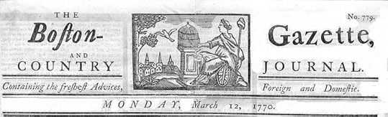

**On the evening of Monday, being the fifth current, several soldiers of the 29th Regiment were seen parading the streets with their drawn cutlasses and bayonets, abusing and wounding numbers of the inhabitants.**

A few minutes after nine o'clock four youths, named Edward Archbald, William Merchant, Francis Archbald, and John Leech, jun., came down Cornhill together, and separating at Doctor Loring's corner, the two former were passing the narrow alley leading to Murray's barrack in which was a soldier brandishing a broad sword of an uncommon size against the walls, out of which he struck fire plentifully. A person of mean countenance armed with a large cudgel bore him company. Edward Archbald admonished Mr. Merchant to take care of the sword, on which the soldier turned round and struck Archbald on the arm, then pushed at Merchant and pierced through his clothes inside the arm close to the armpit and grazed the skin. Merchant then struck the soldier with a short stick he had; and the other person ran to the barrack and brought with him two soldiers, one armed with a pair of tongs, the other with a shovel. He with the tongs pursued Archbald back through the alley, collared and laid him over the head with the tongs.

The noise brought people together; and John Hicks, a young lad, coming up, knocked the soldier down but let him get up again; and more lads gathering, drove them back to the barrack where the boys stood some time as it were to keep them in. In less than a minute ten or twelve of them came out with drawn cutlasses, clubs, and bayonets and set upon the unarmed boys and young folk who stood them a little while but, finding the inequality of their equipment, dispersed.

On hearing the noise, one Samuel Atwood came up to see what was the matter; and entering the alley from dock square, heard the latter part of the combat; and when the boys had dispersed he met the ten or twelve soldiers aforesaid rushing down the alley towards the square and asked them if they intended to murder people? They answered Yes, by G-d, root and branch! With that one of them struck Mr. Atwood with a club which was repeated by another; and being unarmed, he turned to go off and received a wound on the left shoulder which reached the bone and gave him much pain. Retreating a few steps, Mr. Atwood met two officers and said, gentlemen, what is the matter? They answered, you'll see by and by.

Immediately after, those heroes appeared in the square, asking where were the boogers? where were the cowards? But notwithstanding their fierceness to naked men, one of them advanced towards a youth who had a split of a raw stave in his hand and said, damn them, here is one of them. But the young man seeing a person near him with a drawn sword and good cane ready to support him, held up his stave in defiance; and they quietly passed by him up the little alley by Mr. Silsby's to King Street where they attacked single and unarmed persons till they raised much clamour, and then turned down Cornhill Street, insulting all they met in like manner and pursuing some to their very doors.

Thirty or forty persons, mostly lads, being by this means gathered in King Street, Capt. Preston with a party of men with charged bayonets, came from the main guard to the commissioner's house, the soldiers pushing their bayonets, crying, make way! They took place by the custom house and, continuing to push to drive the people off, pricked some in several places, on which they were clamorous and, it is said, threw snow balls. On this, the Captain commanded them to fire; and more snow balls coming, he again said, d--n you, fire, be the consequence what it will! One soldier then fired, and a townsman with a cudgel struck him over the hands with such force that he dropped his firelock; and, rushing forward, aimed a blow at the Captain's head which grazed his hat and fell pretty heavy upon his arm. However, the soldiers continued the fire successively till seven or eight or, as some say, eleven guns were discharged.

http://www.constitution.org/primarysources/boston.html

**London Chronicle Article**

